|  |
| --- |
|  |
| Screen Specifications |
| Add New Book and Register Account |
|  |
| **[Nguyen Quoc Huy]** |
|  |

Table of Contents

[To update the table of contents, right click the message below and select Update Field (F9 on PC, ⌥⌘U on Mac).]

1. Pages 3

1.1. Page Tree 3

1.2. Register Account 4

1.2.1. User Interface 4

1.2.2. Widget Table 4

1.3. Add New Book 5

1.3.1. User Interface 5

1.3.2. Widget Table 5

1.4. Edit Copies 6

1.4.1. User Interface 6

1.4.2. Widget Table 6

1.5. Home 7

1.5.1. User Interface 7

1.6. Book Management 8

1.6.1. User Interface 8

1. Pages
   1. Page Tree

Register Account  
Add New Book  
 Edit Copies  
Home  
Book Management

* 1. Register Account
     1. User Interface

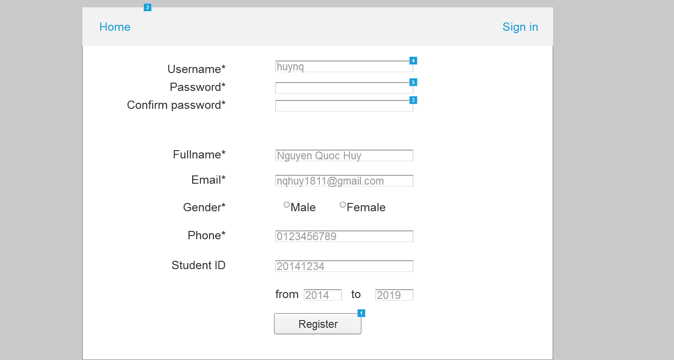

* + 1. Widget Table

| Footnote | Name | Interactions |
| --- | --- | --- |
| 1 | register button | OnClick:  Case 1:  Open Home in Current Window |
| 2 | home button | OnClick:  Case 1:  Open Home in Current Window |
| 3 | confirm password input | OnKeyUp:  Case 1  (If text on This does not equal text on password input):  Set text on (Rectangle) equal to "x"  Case 2  (Else If True):  Set text on (Rectangle) equal to "v" |
| 4 | username input | OnKeyUp:  Case 1  (If text on This equals ""):  Set text on username check equal to "x"  Case 2  (Else If True):  Set text on username check equal to "v" |
| 5 | password input | OnKeyUp:  Case 1  (If text on This does not equal text on confirm password input):  Set text on (Rectangle) equal to "x"  Case 2  (Else If True):  Set text on (Rectangle) equal to "v" |

* 1. Add New Book
     1. User Interface

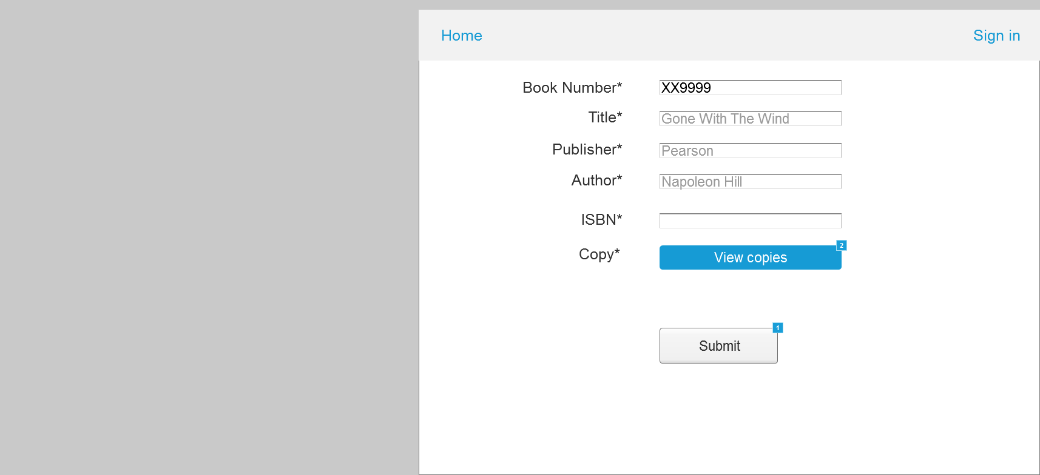

* + 1. Widget Table

| Footnote | Interactions |
| --- | --- |
| 1 | OnClick:  Case 1:  Open Book Management in Current Window |
| 2 | OnClick:  Case 1:  Open Edit Copies in Popup Window |

* 1. Edit Copies
     1. User Interface

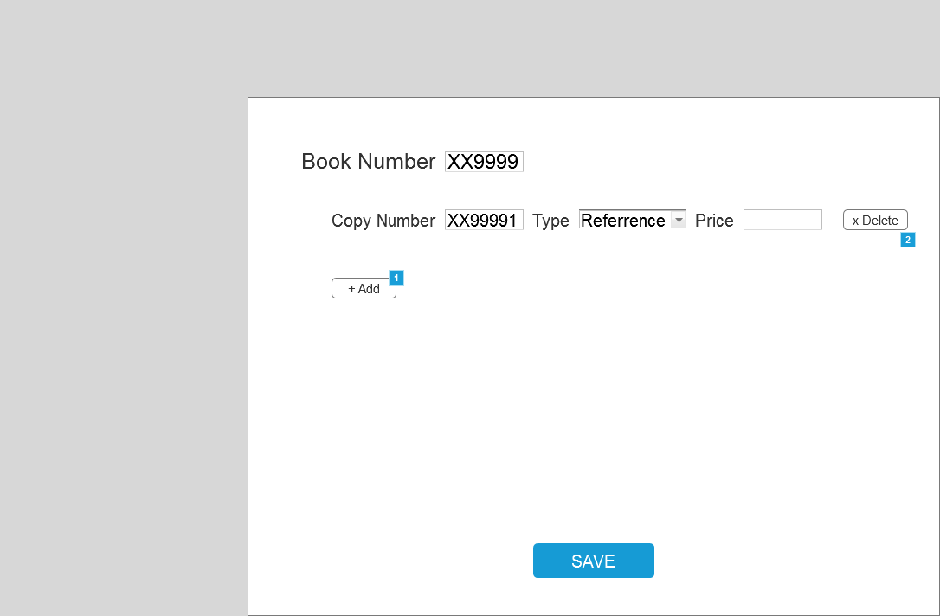

* + 1. Widget Table

| Footnote | Name | Interactions |
| --- | --- | --- |
| 1 |  | OnClick:  Case 1:  Show copy2 |
| 2 |  | OnClick:  Case 1:  Hide copy2 |

* 1. Home
     1. User Interface

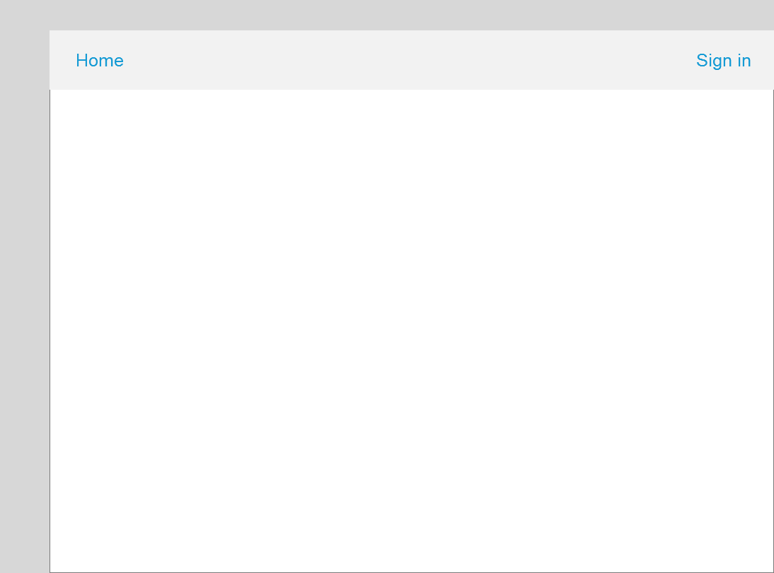

* 1. Book Management
     1. User Interface

